

**Faculty of engineering – Shoubra Benha University**

**Research Article / Research Project / Literature Review**

|  |  |
| --- | --- |
| **Department** | **Engineering Mathematics and Physics** |
| **Division** | **-----------** |
| **Academic Year** | **2019-2020 Preparatory** |
| **Course name** | **Computer** |
| **Course code** | **ECE001** |

**Title(s): -Build a website on topic Programming Language**

**Examiners committee**

|  |  |
| --- | --- |
| **1** | **Dr.Ahmed Bayoumi** |
| **2** | **Dr.Shady Elmashad** |
| **3** | **Dr. Abdelhamid Attaby** |

|  |  |  |  |
| --- | --- | --- | --- |
|  | **Name** | **Edu mail** | **B.N** |
| **1** | **محمد سيد نصر عبدالرشيد** | **Muhammed195811@feng.bu.edu.eg** | **726** |

**Date: 4/7/2020**

**Github link:**

**Github page (published-website):**

**Topic:**

##### Programming Language

**Application Brief:**

A programming language is a formal language comprising a set of instructions that produce various kinds of output. Programming languages are used in computer programming to implement algorithms

Most programming languages consist of instructions for computers. There are programmable machines that use a set of specific instructions, rather than general programming languages. Early ones preceded the invention of the digital computer, the first probably being the automatic flute player described in the 9th century by the brothers Musa in Baghdad, during the Islamic Golden Age.[1] Since the early 1800s, programs have been used to direct the behavior of machines such as Jacquard looms, music boxes and player pianos.

**Importance of Programming:**

So why is programming important in this age? Billions of people are actually using internet as part of their daily life. Wherever you are, you need an access to the internet. In school, in working site, you need an access to the internet in order to be able to compete in the global economy. Global communication also became possible because of internet. Global business is also targeting its success because of internet.

Programming uses codes, the language different to that of human’s, that would command instructions using the internet. Actually, internet has helped a lot people to learn many things in this age. We could increase awareness about the things in the world. Computer programming has allowed many people to access their needs from the computer. Since we are living in an era when we have to use technology, programmers have trod the path of life. Thanks to computer programmers, we could reach the ends of the earth.

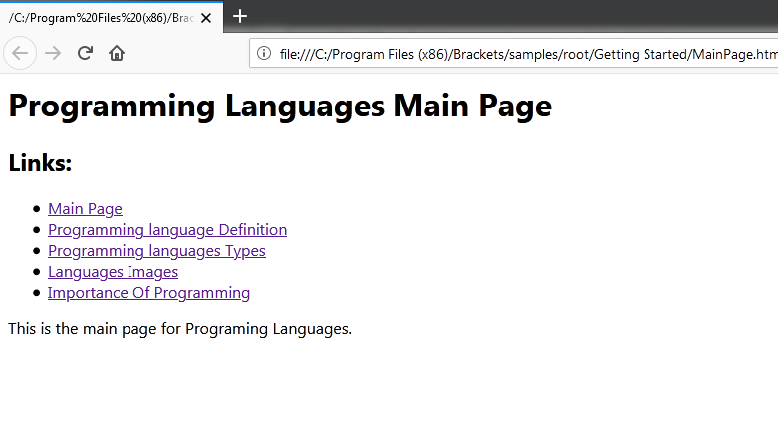**Screenshots:**

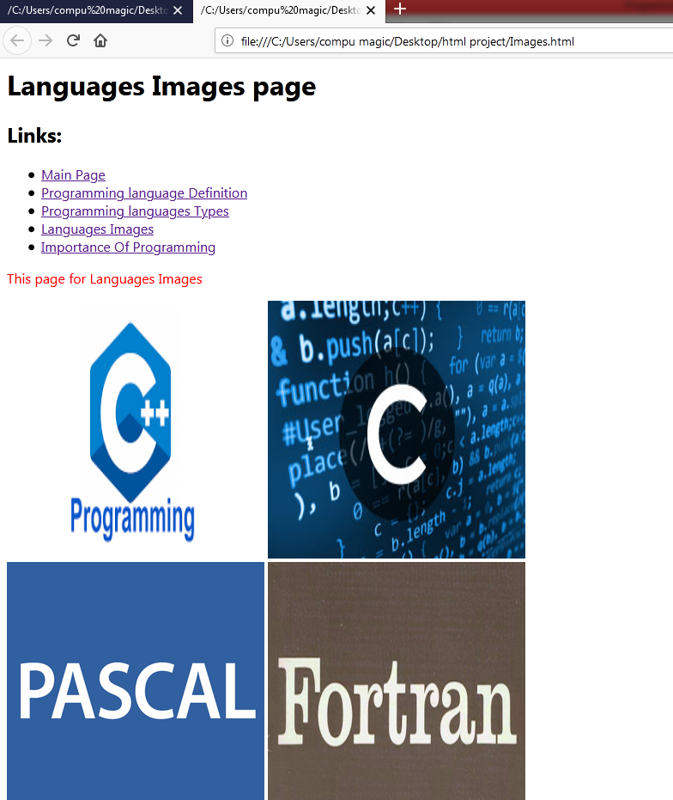

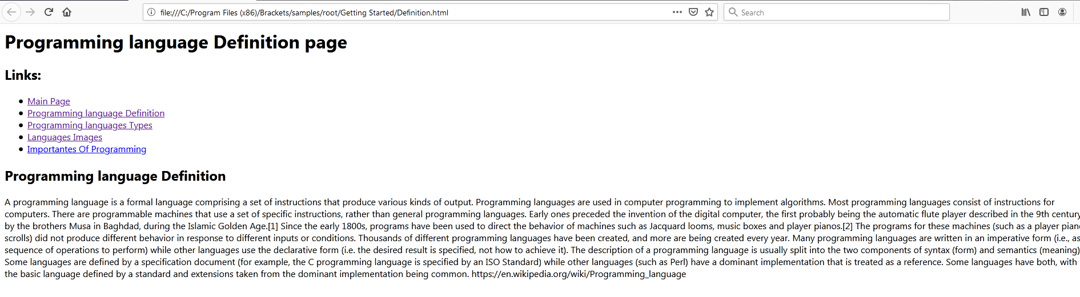

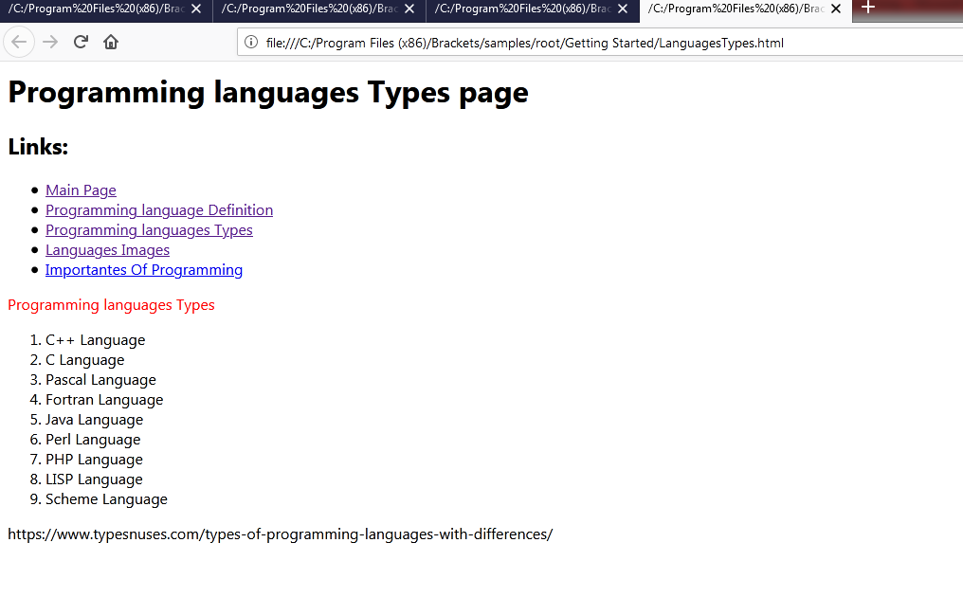

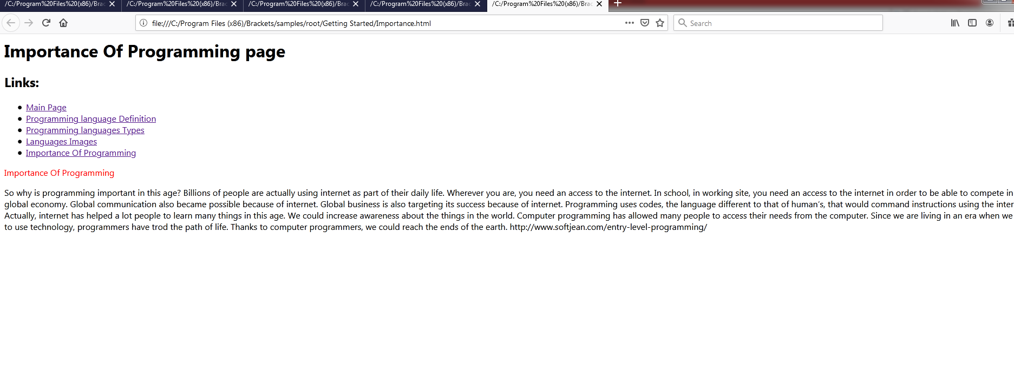

**Source Code:**

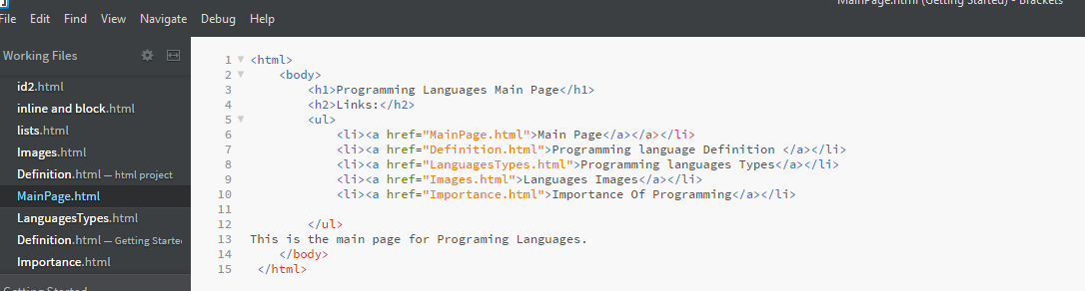

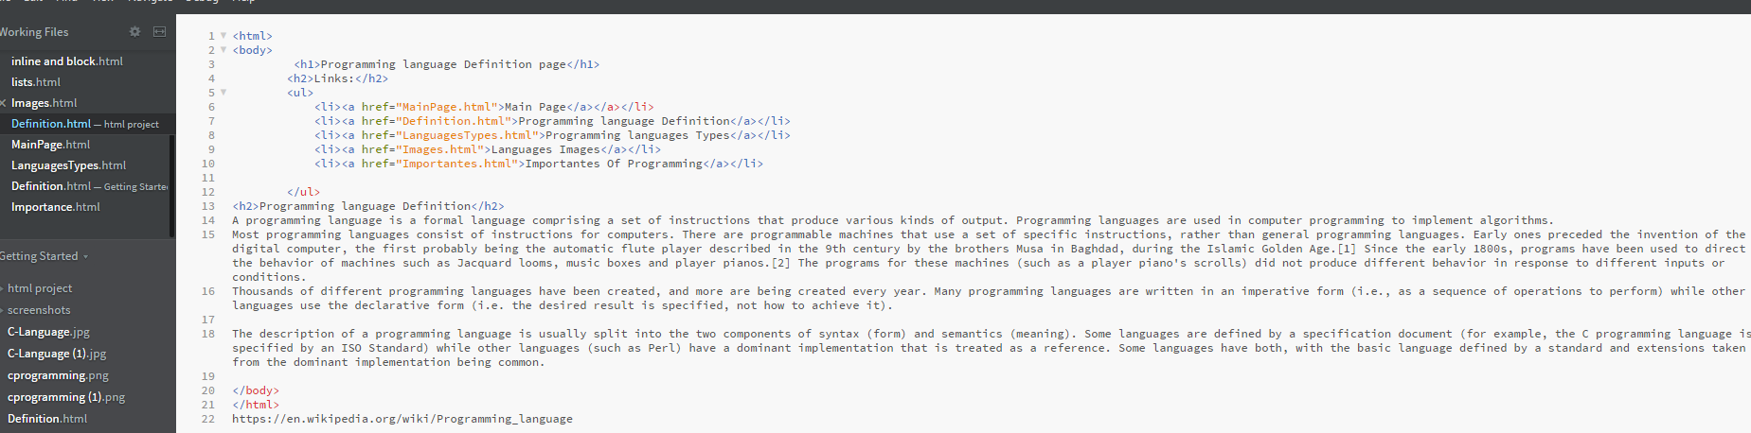

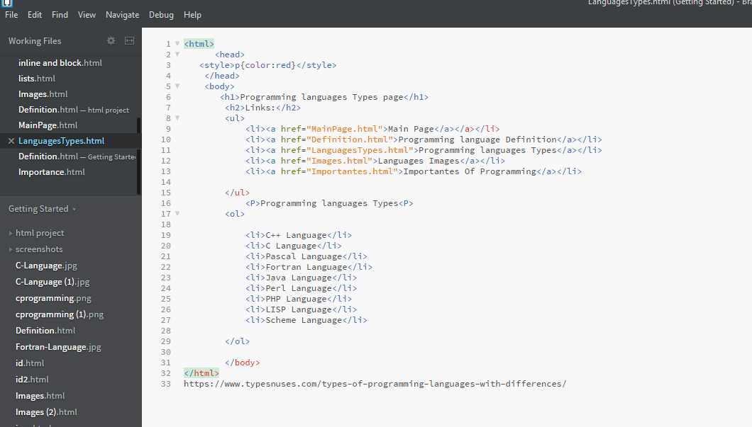

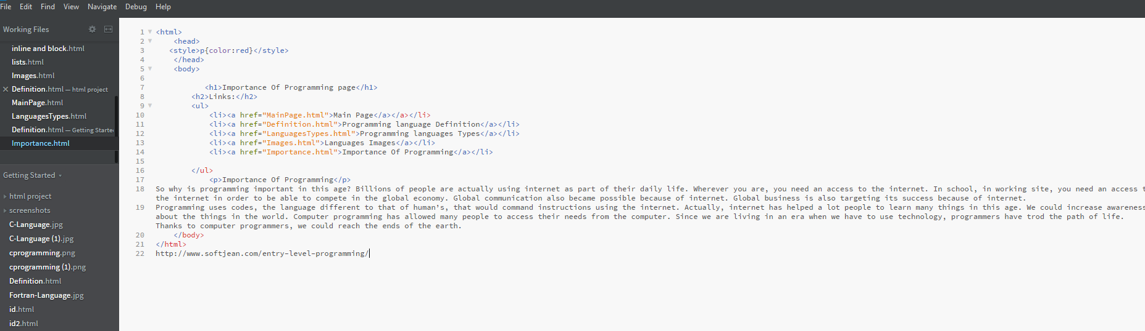

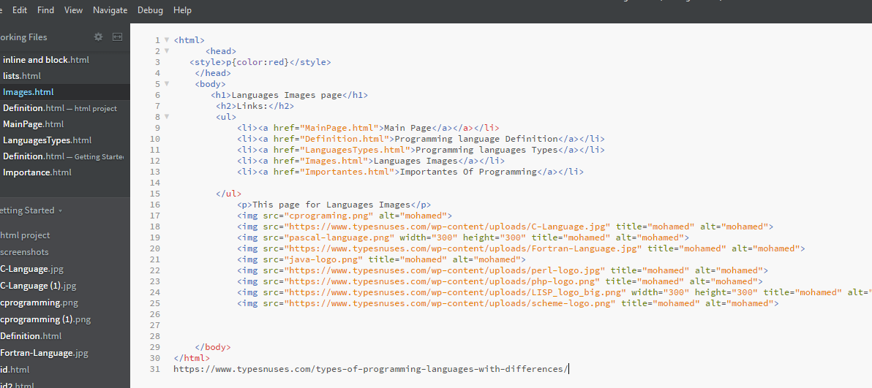

**References**

<https://www.typesnuses.com/types-of-programming-languages-with-differences/>

<https://en.wikipedia.org/wiki/Programming_language>

[https://www.typesnuses.com/types-of-programming-languages-with-differences](https://www.typesnuses.com/types-of-programming-languages-with-differences/)

<https://en.wikipedia.org/wiki/Programming_language>

<http://www.softjean.com/entry-level-programming/>